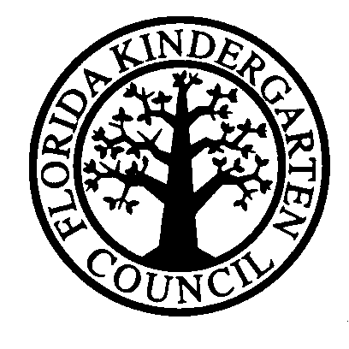

INQUIRY THROUGH ORIGINAL EVALUATION

Please complete Part A and email to malton@fcis.org in FKC Office.
PART A
School |  | Grades Covered:
Address
City, State & Zip
Head Name
Head’s Title
Email and web site | Email: Web site:
Phone and Fax | Ph. : Fax:
Date School Established
School Mission
Type of School | Nonprofit Proprietary Special Education  Boys only School Girls Only School Boys & Girls School  Church/Temple/Mosque related School
Number of Students | Below age 2: 2-3 yrs: 4 yrs :  5 yrs : Grade 1-3: Above Grade 3:
Current Enrollment
Age range
Other Campus Infoformation
Other Accreditations
Written Curriculum | Yes No
State scholarships accepted

PART B: For FKC Office Use Only
Date of Inquiry
Material Sent | Standards Letter FKC Info
Application Request
Application Sent
Application Returned
Request Mentor
Mentor Assigned
Direction to School
Comments/Notes

