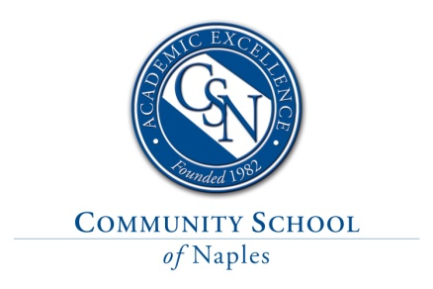
Upper School Chinese Teacher
Position Description and Requirements
Community School of Naples, an independent, college preparatory school, is currently seeking a full-time Chinese teacher who is skilled in teaching all levels, including AP Chinese Language and Culture. The candidate hired will teach five classes, grades 9-12, with the average class size of 8-10 students. The position requires a Bachelor's degree and experience teaching Chinese at the upper school level. Experience teaching in the target language at least 90% of the time and using ACTFL proficiency standards and assessments are a plus, including experience and training with AP Chinese.
This position offers the opportunity to work in a proficiency-based environment where focus on student-created communication of language is built through a well-articulated curriculum. Community School of Naples has state-of-the-art language learning resources to support teaching and learning, thus engaging students as enthusiastic learners.

CSN is one of the top independent, non-sectarian day schools in Florida and maintains a PK-12 school enrollment of 950 students. CSN students are consistently top-ranked when compared to all other Southwest Florida high schools when it comes to test scores, extracurricular activities, and college acceptances. New academic initiatives, such as the Scholars Program, AP Capstone Diploma, and Global Exchange Program, ensure that both students and faculty have the opportunity to grow and develop into world-class thinkers and leaders.
Compensation and Benefits
This full-time, instructional position starts August 5, 2022 and is paid on an annual salary commensurate with experience, degree attainment, and qualifications. The competitive benefits package includes medical, dental, vision, disability, AD&D, life insurance, and options for pet, Aflac and Legal/Identity Shield; in addition to eligibility for the company’s generous 403(b) retirement program. Please visit our website for more details about the benefits of a career at CSN.
Applying
Only electronic applications will be accepted. Please do not mail, fax, email or drop off your application/resume. Please submit your electronic application by clicking on the link below:
https://communityschoolnaples.tedk12.com/hire/index.aspx
- Community School of Naples is an Equal Opportunity Employer.
- Fingerprinting and background checks are a required part of CSN’s employment eligibility process.

