Teaching and Learning Online
Teaching and learning online are just as unique as teaching and learning in the traditional classroom. Although standards, goals and activities are similar, the way the teacher engages students is key. There is no one size fits all, but some of these suggestions may help. None are mine, they all came from Florida Virtual Elementary teachers who created them. Have fun developing your own style.
Set up your classroom. You are on camera and must look the part of teacher – dress and do your hair. Use a headset to minimize audio issues. Organize your props to use in front of the camera. Use a backdrop that looks like school, not a bedroom with an unmade bed. Check yourself on camera to see how you look. Always do a sound check prior to starting. If you need a glass of water, and you will, keep it handy and remind children about the importance of staying hydrated.
Develop a plan or schedule that works for you and share this with the parents, they know the importance of structure in young people’s lives- remember, the younger the child, the stronger the structure. You provide the structure, time frame, schedule. Also remember that the brain shuts down after 20 sedentary minutes so get the students moving- take a brain break, you will need them also. Anything you ask a student to do, you do along with them. Hope three times, you show them how. The camera is a powerful tool.
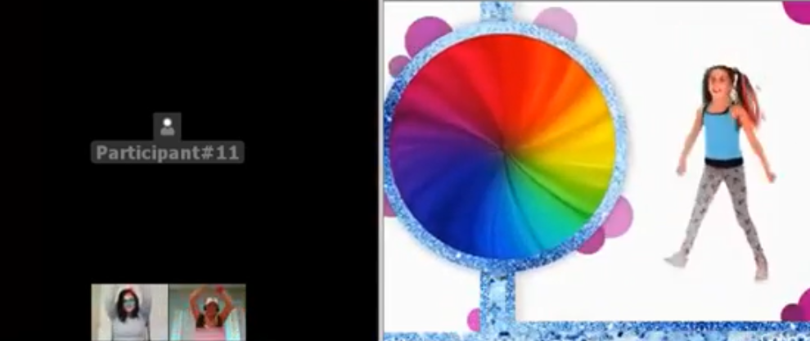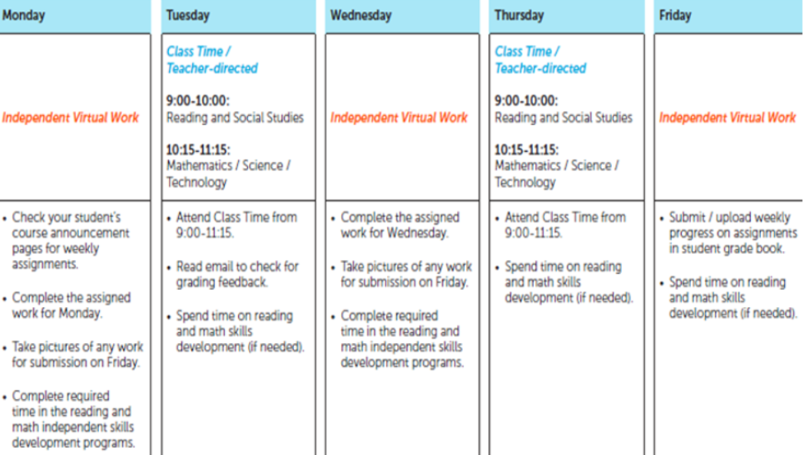

Always go online early. Expect the unexpected. Each platform is different (canvas, Blackboard, Zoom) and each takes practice to use. You improve with each lesson. Try adding one new feature to each lesson, not everything at one time. Assimilation and accommodation works for all learners. Keep balance for yourself and your students. Learn how to give students their privileges and how to remove them. You think no one will challenge the rules, but they will and you have to oversee them, just as you do in the traditional classroom. You have the power to silence them (take their talking or writing privileges away. If you have a student who needs more support, take them into a break-out room at the end of the session and discuss the online expectations. Make sure parents are online with the youngest students until they become capable of manipulating on their own. This differs per child and age group.
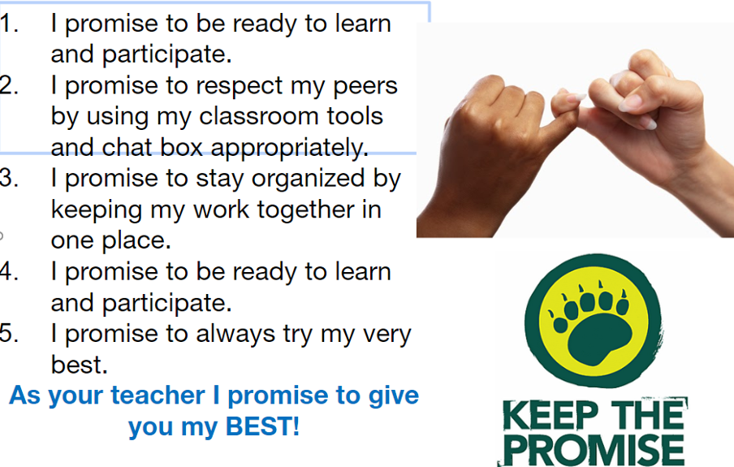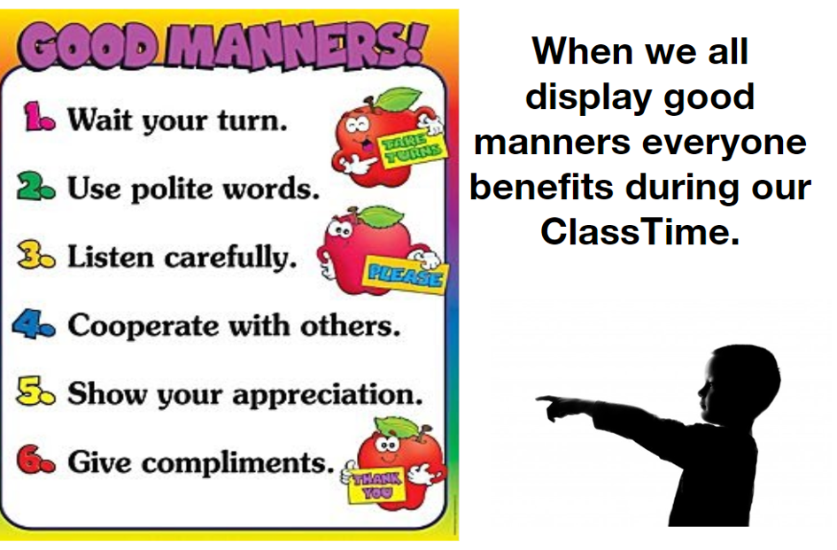
Plan a 40 minute lesson – no more. That’s not 40 minutes of you talking- you provide the interactives- here are some ideas- First of you have to get their attention! People will not all be in your virtually setting at the same time, they will get knocked out, be late, have an issue getting on and you can’t go back over and over again to restart, so have an activity up for all to get their attention, get them working, get them excited about the lesson. Here are some ideas –
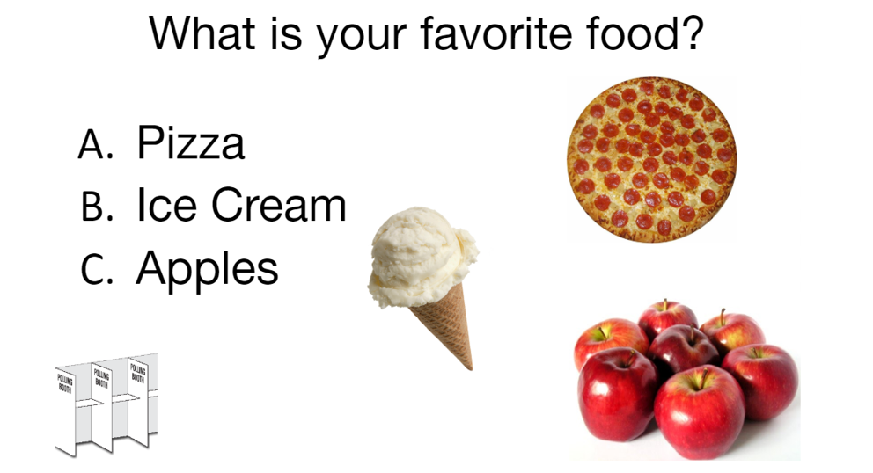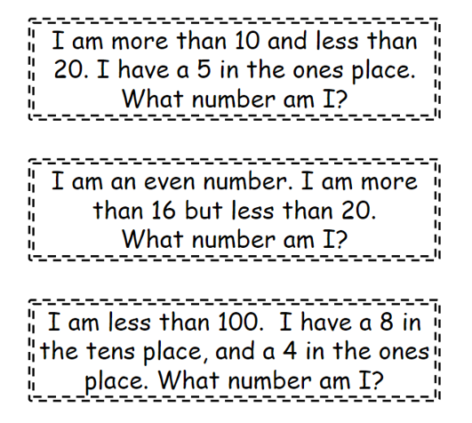
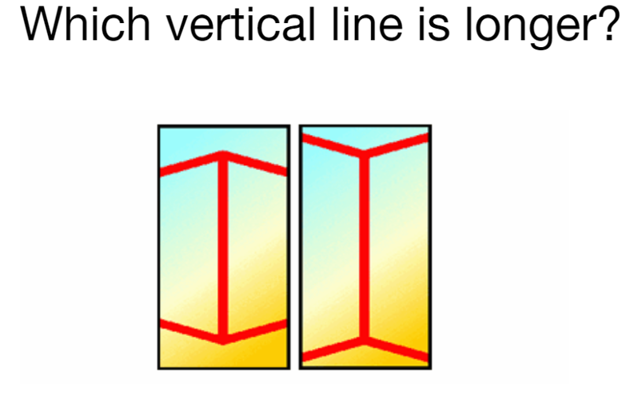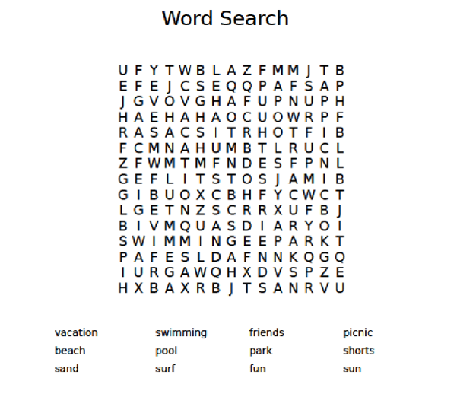
Do not expect people to “just know” how to work online. You have to show them online where buttons are, what is expected, how it works and dry runs are useful.
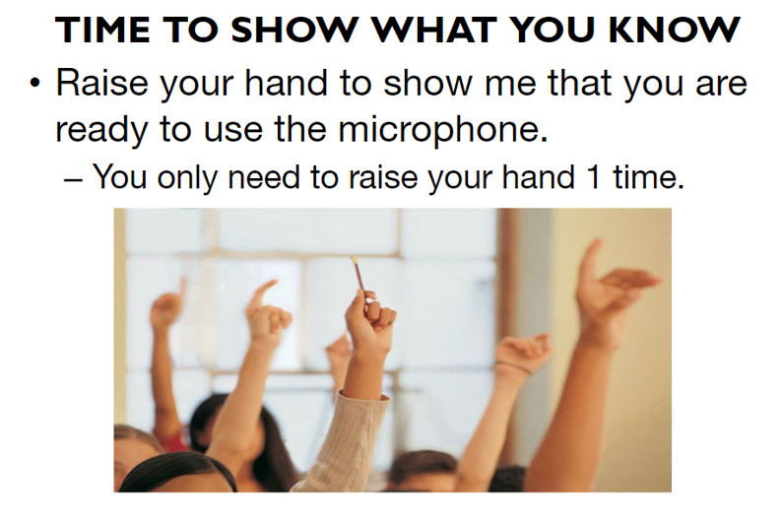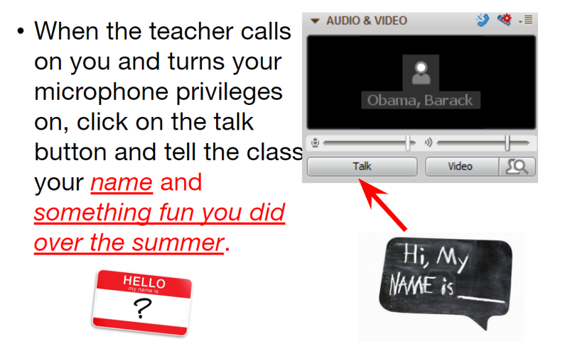
Use lots of pictures to help the youngest know what is expected- create your own icons – it’s easier and quicker to get a message from an icon – so use them- here are some examples our teachers at FLVS Elementary created-
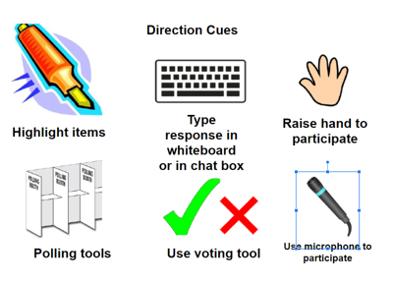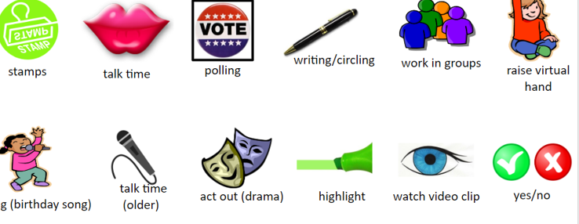
Planning Time – putting a lesson online is extremely time consuming- expect to take four hours to provide a 40 minute lesson, then expect the students to amaze you with how easily they learn from this powerful tool. It is not easy to design online lessons, but this is your opportunity to do what you have been wanting to do for a long time, teach students. Work as a grade level and divvy up the work, share the slides, everyone will put their own spin on the lesson. Anything you can teach in real life can by taught and learned online, it’s up to you to figure out how. Children believe you are talking right to them and the one on one intensive lessons work very quickly and rarely require remediation. Virtual delivery is individualization on steroids.
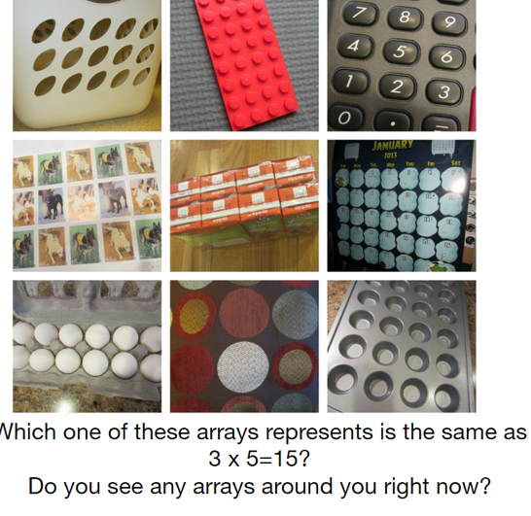
End every session with a celebration of learning – same as a revelation of what they learned- powerful motivator –
