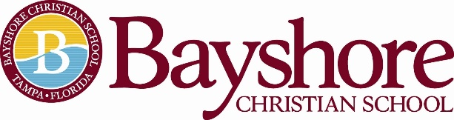
Bayshore Christian School is a private, evangelical, non-denomination Christian school serving students PK2-12th grade. Located in the heart of South Tampa, close to the Selmon Expressway and MacDill Air Force Base with easy access to the Brandon/Riverview area and St. Petersburg. Bayshore is widely recognized for its strong academics and Christ-centered, family environment.
We are seeking passionate candidates for a full time 2-year old preschool teaching position starting with the 2021-22 academic year.
Identification:
Instructional Teacher Preschool 2-year old Teacher
Early childhood training and preschool education focuses on beginning development in language, phonics, numerical, physical, social and emotional development.
Students: 2 and 3 year old students
Direct Supervision: Dean of Administration
Scope of Work: Full Time: Ten-month position

August 1, 2021 - May 30, 2022
Professional Qualifications
Preschool Teacher of a Two Year Old Class:
- One of the following degrees:
  - A bachelor’s degree with evidence they are qualified in early childhood education or a related field
  - An Associate of Arts degree in early childhood education or child development
- Preferred Florida Department of Children and Families childcare staff credentials
- Applicant’s willingness to sign an intent to begin DCF childcare staff credentials within 90 days and complete the staff credentials within one year of hire.
- Minimum of 1 year experience in a preschool program-preferred

Professional Behavior:
- The teacher is an evangelical, born again Christian.
- The teacher will regularly attend an evangelical, Christian church for spiritual growth.
- The teacher will adhere to Bayshore Christian School’s Faculty and Staff Handbook.
Please visit www.bayshorechristianschool.org to complete an online application. Submit your resume to Melanie Humenansky, Head of School at mhumenansky@bayshorechristianschool.org

