SJEDS FACULTY MEMBER
At San Jose Episcopal Day School (SJEDS) everything we do is a loving and joyful expression of our mission, which is to inspire a passion for learning, a life of integrity, and a heart for Christian service. Our faculty are the heart of our school, beloved by students and parents alike for their warmth, responsiveness, creativity, professionalism, and their exceptional commitment to helping each and every child meet his or her great potential. Lifelong learners themselves, our faculty model the characteristics they seek to cultivate in their students: love, wisdom, open-mindedness, responsibility, service, honesty, respect, patience, faith and gratitude.
KEY ATTRIBUTES
Our faculty are responsible for planning, preparing, and delivering active, interactive, challenging, and purposeful learning experiences that ignite the imaginations of our students and inspire a lifelong love of learning. Our faculty take their responsibilities seriously, but they approach their work with a playful spirit. They relish cross-grade level and departmental projects and seek out opportunities to tinker with new techniques and resources. Aspirational by nature, our faculty are also researchers, continuously collecting formative and summative assessment data and using it to track student progress and to inform future instruction. With small class sizes, they delight in partnering closely with students and families to help each learner achieve their personal goals. Our faculty use the Responsive Classroom approach to build safe, positive, and inclusive classroom communities, to manage effectively, to offer challenging and engaging academics, and to match their instruction to the developmental strengths and needs of their students.

RESPONSIBILITIES
SJEDS Faculty members
- Adhere to the school’s Faculty Characteristics of Professional Excellence and the guidelines put forth in our Faculty Handbook
- Embrace and live out the school's mission and educational philosophy
- Demonstrate careful preparation for instruction, a commitment to utilizing best practices in teaching and learning, and effective strategies for evaluating all students' progress continuously and effectively
- Develop and maintain a classroom atmosphere that is emotionally safe, respectful, positive, encouraging, and inclusive, using management and teaching strategies that cultivate the spiritual, social, and emotional skills and wellbeing of our students
- Cultivate close-knit, trusting relationships with parents through frequent and respectful communication
- Support the broader needs of the school community, including, but not limited to participation in school professional development initiatives, community events, service and outreach opportunities, committee membership, parent and faculty meetings, and other commitments as requested by Administration.
- Practice discretion and confidentiality
- Demonstrate a lifelong commitment to remaining on the front edge of the Education (or related) field, seeking out opportunities to use emerging research to inform practice and remaining open to new approaches, techniques, and resources.
- Maintain professional credentials and/or certification

QUALIFICATIONS
SJEDS Faculty members have
- A bachelor's degree in Education or a related field
- A proven record of excellence in teaching
- A broad knowledge of educational technology applications and software
- Strong written and verbal communication skills
- Strong collaboration skills
- Strong cultural competencies
- A current state teaching certification
- Credentials that meet FCIS’ Teaching Requirements

Faculty Characteristics of Professional Excellence

The following characteristics reflect our mission
expressed through the lives and work of our faculty and staff.

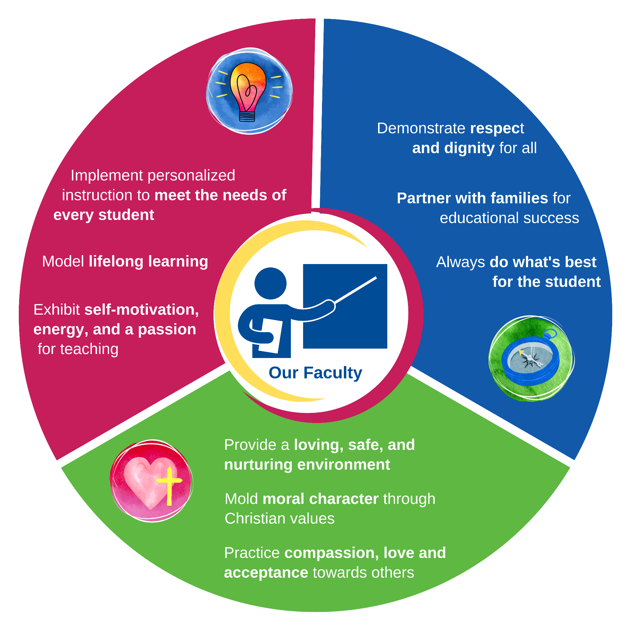
San Jose Episcopal Day School is an equal opportunity employer. We believe in hiring a diverse workforce and sustaining an inclusive, people-first culture. We are committed to non-discrimination on any protected basis, such as disability and veteran status, or any other basis covered under applicable law.

TO APPLY

- Send Cover Letter and Resume to DFO, Stacey Stec, sstec@sjeds.org.

Inspiring a passion for learning, a life of integrity, and a heart for Christian service

