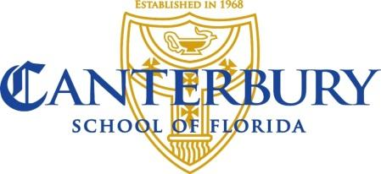

Middle/Upper School Science Instructor
Canterbury School of Florida is seeking an experienced and dedicated Middle/Upper School Science Instructor to teach multiple levels of science curriculum for the 2021-22 school year. This instructor will collaborate closely with the science and marine studies faculty. This candidate will also implement LEADS (Canterbury’s character education program) through advisory and will be expected to perform various duties that support the Knowlton Campus.

In addition, this teacher will have a commitment to the School’s mission and an interest in community involvement through participation in school-wide committees and activities. It is expected that each faculty member contributes to a positive culture by building collaborative, collegial, and respectful relationships with colleagues and overtly supporting fellow teachers and administrators.

Skills and Abilities
- Understanding of the cognitive and developmental needs of children
- Experience with project-based and hands-on learning
- Clear understanding of differentiated instruction
- Excellent communication skills, both oral and written
- Proficient at designing and using assessments to guide instruction
- Commitment to professional development
- Proficient in educational technology

Educational and Other Requirements
- Bachelor’s Degree required. A Master’s degree in education or science is preferred.
- Successful completion of pre-employment background screening, drug testing, and safety training required.

Interested applicants should send a letter of interest and resume to Donnamarie Hehn, Upper School Principal at dhehn@canterburyflorida.org.

