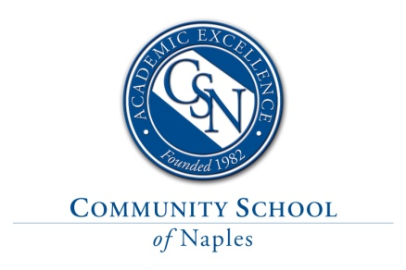
Middle School Computer, Technology, and Innovation Elective Teacher

Community School of Naples, an independent, college preparatory school, is seeking a motivated and talented middle school Computer, Technology, and Innovation Elective Teacher for a new, full-time position in our Computer Science Department.
Description and Requirements
The 2021-2022 teaching responsibilities include elective titles such as Scratch Programming, Python Games, STEM, Moviemaking, Inventor’s Workshop and/or EXCEL. The specific teaching assignment will depend on a candidate’s background and abilities. This position requires a Bachelor’s degree in Computer Science, Engineering, Math, Science, or a similar STEM field, and at least 3 years of relevant teaching experience at the middle school levels. Passion for and experience with MakerSpace, Design, or other STEM-related fields is also a plus. This is a growth position, reflecting the excitement and popularity that programming and technology-based courses have at our school.
This position would include up to 5 classes a day, and the average class size would be approximately 10-14 students. The ideal candidate would also be willing to mentor additional clubs such as Robotics or Programming, both of which compete at the local, state, and national levels. Prior experience in engineering, project-based learning, and/or design work is desirable. Strong communication skills and the ability to inspire students to innovate and create are essential. The ideal candidate for this position is a person with wide-ranging interests who is eager to embrace the challenges and benefits of connecting computer science to our challenging, exploratory, and engaging middle school STEM program.
CSN is one of the top independent, non-sectarian day schools in Florida and maintains a PK-12 enrollment of 870 students. CSN students are consistently top-ranked when compared to all other Southwest Florida high schools when it comes to test scores, extracurricular activities, and college acceptances. New academic initiatives, such as the Scholars Program, AP Capstone Diploma, and Global Exchange Program, ensure that both students and faculty have the opportunity to grow and develop into world-class thinkers and leaders.
Compensation and Benefits
The appointment will be for the academic year starting August 7, 2021. The appointment is a full-time, instructional position that will be paid on an annual salary commensurate with experience, degree attainment, and qualifications. The competitive benefits package includes medical, dental, vision, disability, AD&D, life insurance, and eligibility for the school’s 403(b) retirement program. Please visit our website for more details about the benefits of a career at CSN.
Applying
Please apply via our online application portal only, which allows for uploading of supporting documents. Please do not mail, fax, email, or drop off your resume/application. https://communityschoolnaples.tedk12.com/hire/index.aspx
Please include a cover letter, teaching philosophy and references as well as instructions about contacting your current employer by attaching these documents to your application. If needed, cover letters and additional supporting documents may be emailed to dpainter@communityschoolnaples.org; they will be forwarded to the selection committee.

- Community School of Naples is an Equal Opportunity Employer.
- Fingerprinting and background checks are a required part of CSN’s employment eligibility process.

