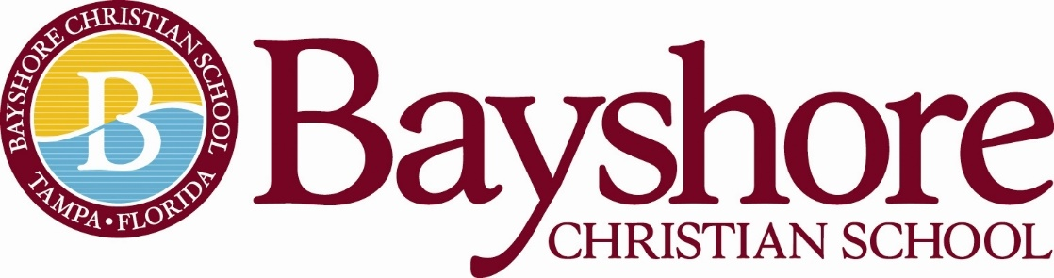

Upper Division Science Teacher

Full Time Employee: 10-month position
School Year Hours: 7:45am-3:15pm
Summer Hours: NA
Direct Report: Head of School/ Dean of Academics

Job Description:

An Upper Division science teacher provides instruction and guidance to help students explore and understand important concepts in science, including problem-solving and how to gather evidence to support ideas or decisions. Science teachers create lesson plans, present science demonstrations, and grade tests and assignments.

Classes include but are not limited to:
- Physical Science
- Biology
- Anatomy
- Forensic Science
- Chemistry
- Physics
- Marine Biology

Job Responsibilities:

Science teachers are responsible for preparing class lesson plans based on school guidelines and grade levels. This may include preparing daily instruction outlines, classroom assignments, special projects, homework, and tests. A teacher must maintain student records to show attendance, grades, and conduct in accordance with school and state policies. A teacher also needs to observe and evaluate each student’s performance. At times, parent and student conferences are conducted to discuss student progress or concerns. Teachers of any subject should have excellent written and verbal skills and be able to communicate effectively with students, parents, and colleagues. Science teachers must be detail-oriented, effective at problem-solving, and have excellent instructional skills. A teacher should also be willing to become involved in extracurricular activities, such as athletics and school clubs.

- Create daily lesson plans and learning activities for students based on national, local and school standards in science education and research and knowledge of developmental behaviors.
- Deliver high-quality, engaging instruction in the form of discussion, direct teaching, demonstrations and independent practice using a variety of proven methods.
- Differentiate lessons when needed to give all students access to the curriculum regardless of disability, instructional level, English proficiency or level of interest in the subject.
- Evaluate student performance on tasks established by the standards using different methods such as observation, performance-based tasks or other standard test practices.
- Maintain a safe, orderly and supportive classroom by modeling expected behavior and standards, promoting positive interactions and quickly addressing behaviors that are not in line with the school discipline plan.
- Communicate with parents regarding student progress, potential and behavior periodically through phone or electronic means and at parent and teacher conferences.
- Improve skills and knowledge in teaching by regularly taking classes, attending workshops and discovering new methods of delivering exciting content to students.

Live the Biblical Characteristics of Professional Excellence of
Bayshore Christian School

Minimum Qualifications/Training and Experience

- Previous experience working in a school environment and leading student programs.
- Demonstrated spiritual maturity.
- Bachelor’s degree or equivalent relevant experience.
- Bachelor of Science in Secondary Education
- Preferred minimum three years teaching experience at the middle school or high school level but not required
- The teacher has a minimum of a Bachelor’s Degree.
  - Preferred Degree in education but not required.
  - Professional teaching certification preferred but not required.
    - Applicant’s willingness to sign an intent to earn for a teaching certificate in the state of FL within three years of hire.
- Good oral and written communication skills.
- Proficient use of technology.
- Planning and organizational skills.

Professional Behavior:
The teacher is an evangelical, born-again Christian.
The teacher will regularly attend an evangelical, Christian church for spiritual growth.
The teacher will adhere to Bayshore Christian School’s Faculty and Staff Handbook.

Mission and Vision:
The philosophy of Bayshore Christian School underlies the development and maintenance of the school’s entire program. This philosophy encapsulates our motto, vision, mission, and core values.

MOTTO
“We are Bayshore: Scholars, Leaders, Faith Warriors”

VISION
Shaping young people in Christ to make an impact in the world.

MISSION
Bayshore Christian School challenges, develops, and empowers students for leadership by following the example of Jesus to “grow in wisdom, stature, and in favor with God and man.” Luke 2:52

Statement of Faith
The Statement of Faith does not exhaust the extent of our faith. The Bible itself is the sole and final source of all that we believe. We do believe, however, that the Statement of Faith accurately represents the teachings of the Bible and therefore, is binding upon all teachers.
- We believe in God, the creator of heaven and earth.
- We believe God created male and female in His image.
- We believe God consecrated marriage as the union of a man and a woman.
- We believe in the trinity: God the Father Almighty, Jesus Christ, his only Son, and the Holy Spirit.
- We believe that Jesus is Lord; that he is divine, that he is God.
- We believe that Jesus was conceived by the Holy Spirit.
- We believe that Jesus was born of a virgin.
- We believe that Jesus atoned for the sins of all mankind when he was crucified.
- We believe that Jesus died and was buried.
- We believe that Jesus was resurrected from death and is alive today.
- We believe that Jesus sits at the right hand of the God the Father Almighty.
- We believe that Jesus will return to this earth to judge all mankind.
- We believe in everlasting life.
- We believe in the Bible as the inspired word of God, inerrant and true.

This job description does not list all the duties of the job. The candidate will also be expected to assist in all-campus activities including but not limited to: Open Campus, Annual Fund, Fun Run, Christmas Musical, Spring Gala
Bayshore Christian School reserves the right to revise this job description at any time.
Above all else, he/she can support and uphold the Head of School and the Administration in all endeavors and presents a united front to students, teachers, staff, Trustees, and all constituents.
Contact Person: Please email a resume and letter of interest to Head of School, Melanie Humenansky at mhumenansky@bayshorechristianschool.org Please include any experience you may have in the area of marketing and communications, coaching, and/or sponsoring extra-curricular activities.

