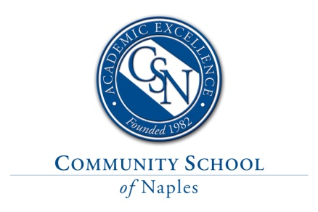

Upper School English Teacher

Position Description & Requirements
Community School of Naples, an independent, college preparatory school, is currently seeking a motivated and talented Upper School English teacher for freshmen and sophomore English. This is a growth position based on projected US enrollment. The minimum candidate qualifications are a bachelor’s degree in English Literature or a closely related field and at least three years’ teaching experience at the high school level. A graduate degree, more than five years’ teaching experience, previous experience within an independent school, and the ability to teach a variety of levels, including AP, are strongly preferred. Teaching responsibilities will include 5 sections of English, with a class size average of 14-16 students. Other responsibilities include serving as an advisor to a group of students and sponsoring English-related clubs as needed.

A CSN English teacher will demonstrate both passion and expertise in the teaching of English language and literature. Through careful, active reading and the respectful exchange of ideas in discussion, our students come to understand rich texts, recognizing the intentional choices of writers--from diction and syntax to patterns of allusion and figurative language--and appreciating how those choices create meaning. We want our students to become lifelong readers who reach for a book both for pleasure and for their own edification, acknowledging the many ways that literature allows us to explore the full scope of the human experience.

A focus on clear, effective critical reading, thinking, and writing skills is at the heart of what we do. To that end, requirements for qualified candidates include

- Experience teaching, evaluating, and responding clearly to student writing
- An understanding of and a commitment to each phase of the writing process
- Development of a vibrant, challenging curriculum, including a robust independent reading program
- Facilitation of meaningful, mature, student-centered discussion
- A willingness to advise student publications
- Balanced integration of technology
- A commitment to ongoing professional development
- The ability to work both independently and within a dynamic, forward-thinking, and cohesive team of fellow English teachers

Compensation and Benefits
This full-time, instructional position starts August 5, 2022 and is paid on an annual salary commensurate with experience, degree attainment, and qualifications. The competitive benefits package includes medical, dental, vision, disability, AD&D, and life insurance, in addition to eligibility for the company’s 403(b) retirement program. Please visit our website for more details about the benefits of a career at CSN.

Applying
Please submit your electronic application at https://communityschoolnaples.tedk12.com/hire/index.aspx where you can upload your cover letter, resume, teaching philosophy and other supporting docs. Please do not mail, fax, email or drop off your application/resume as applications will only be accepted via the link above.
- Fingerprinting and background checks are a required part of CSN’s employment eligibility process.
- Community School of Naples is an Equal Opportunity Employer

