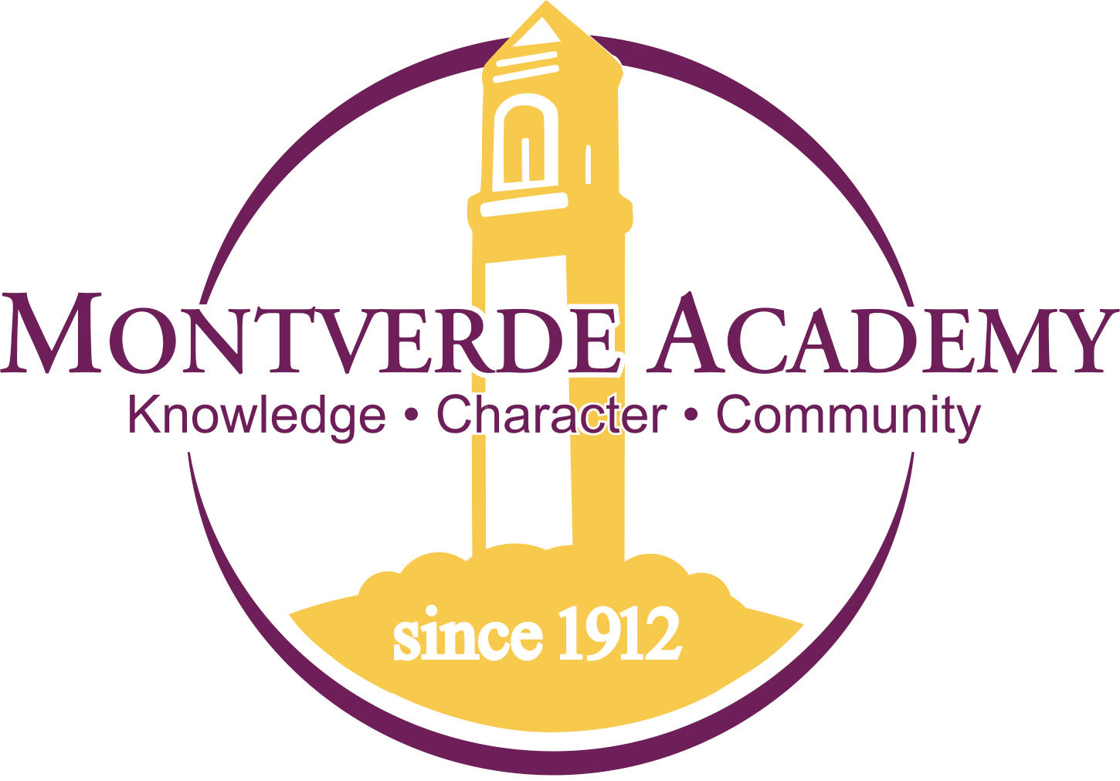 | Montverde Academy  Company Profile: Montverde Academy is an independent boarding and day school comprised of 1000 students from over 60 countries. Our college prep curriculum ensures a 100% college acceptance rate and our students have the foundation to succeed in top notch Division I and Ivy League colleges and universities.
Job Title: | Learning Support Specialist/Teacher | Reports To: | Director of Learning Support Services and Academic Deans
Job Description: Provide a full range of academic assistance to students in 6th-12th grade. The Learning Support Specialist/Teacher assumes duties and responsibilities from the Director of Learning Support Services’ description as directed and supervised by the Dean of the Upper School, Dean of the Middle School and Director of Learning Support Services. These responsibilities include, but are not necessarily limited to, the following areas listed below.
Responsibilities:
- Have an in-depth and working knowledge of learning disabilities or other diagnosis that would warrant educational accommodations.
- Provide in-service opportunities for fellow teachers on how to support students with varying learning needs
- Provide various test accommodations for subject area tests in Middle and Upper School
- Serve as a test proctor for students with accommodations on standardized test such as PSAT, SAT, AP and ACT
- Teach students various strategies for planning, time management, and organizational skills
- Demonstrate good study & test taking skills to students in preparation for test & quizzes
- Provide support on homework, projects, and essays
- Track students’ progress in all subject areas
- Monitor students’ grades for any low assignment grades or missing assignments
- Be comfortable assisting students with relearning and practicing math concepts from 6th Grade Math to Algebra II and Geometry
- Be comfortable assisting students with writing assignments and editing skills
- Communicate regularly with teachers and staff about students’ learning needs
- To provide guidance to fellow faculty on the choice of appropriate teaching and learning methods, provision of approved accommodations
- Communicate effectively with parents regarding the student’s progress as well as difficulties or struggles

Qualifications:
- Teaching experience with students with Learning Differences. Certification or course work in the field of Special Education preferred.
- A combination of education and experience equivalent to college work completed after graduating from high school.
- Experience in an academic setting is preferred
- Strong oral and written communication skills
- The ability to work with and communicate with a diverse population of constituents
- The ability to work with upper and middle school age students, parents, and colleagues
- The ability to assemble, organize, and prepare data for records and reports
- Strongly proficient in Microsoft Office including Outlook, Word, and Excel
- Strong organizational skills with the ability to maintain accurate records
- The ability to maintain strict confidentiality when it comes to school business
- The willingness to learn new skills appropriate for the position
- The ability to work in a dynamic environment dealing with a wide variety of challenges
- The ability to work under pressure while holding one’s composure
- The ability to accomplish assigned tasks with specified deadlines

