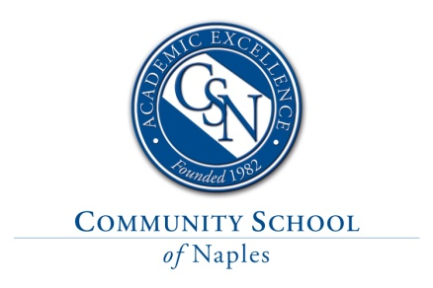

Middle School Spanish Long Term Substitute Teacher for Spring 2023
Position Description & Requirements
Community School of Naples, an independent, college preparatory school, is currently seeking a Middle School Spanish Substitute Teacher for a long-term assignment, starting March 13, 2023 through the end of the school year on May 25, 2023. See daily schedule below. This position requires a Bachelor’s degree (Master’s Degree preferred) and at least two years of teaching Spanish at the middle school level. Experience teaching in the target language at least 90% of the time and using ACTFL proficiency standards, along with proficiency-based assessments are preferred.
Teaching responsibilities will include middle school Spanish language courses with an average class size of approximately 8-15 students. Duties include lunch coverage on a rotating schedule.
This position offers the opportunity to work in a proficiency-based environment where focus on student-created communication of language is built through a well-articulated curriculum. Community School of Naples has state-of-the-art language learning resources to support teaching and learning, thus engaging students as enthusiastic learners.
Schedule:
9:50AM-10:35AM - 3rd period - Spanish A
10:40AM-11:20AM – 4th period - Free
11:25AM12:25PM – Lunch duty on rotation
1:20PM-2:05PM – 6th period - Spanish A
2:10PM-2:55PM – 7th period - Spanish A
3:00PM-3:30PM – 8th period - Study Hall – this is an optional opportunity for more hours

Compensation and Benefits
All subs are paid hourly in compliance with our ACA reporting requirements. Effective September 1, 2022; the Short-term rate is $18.50/hour and the Long-term rate is $19.50/hour. Long-term assignments are twenty-one (21) or more consecutive Work/School days in the same assignment (same teacher/same students). All substitute teachers are eligible to participate in CSN’s retirement plan, Aflac offerings, Legal Shield/Identity Shield, Pet Insurance, and TeleDoc at group rates.
Applying
Please apply by using the online application via the link below. Hard copies, e-mails and faxes will not be recorded or stored. The online application includes features to attach your cover letter, resume, reference letters and educational philosophy and any other supporting documents.

https://communityschoolnaples.tedk12.com/hire/index.aspx

- Community School of Naples is an Equal Opportunity Employer.
- Fingerprinting and background checks are a required part of CSN’s employment eligibility process.

