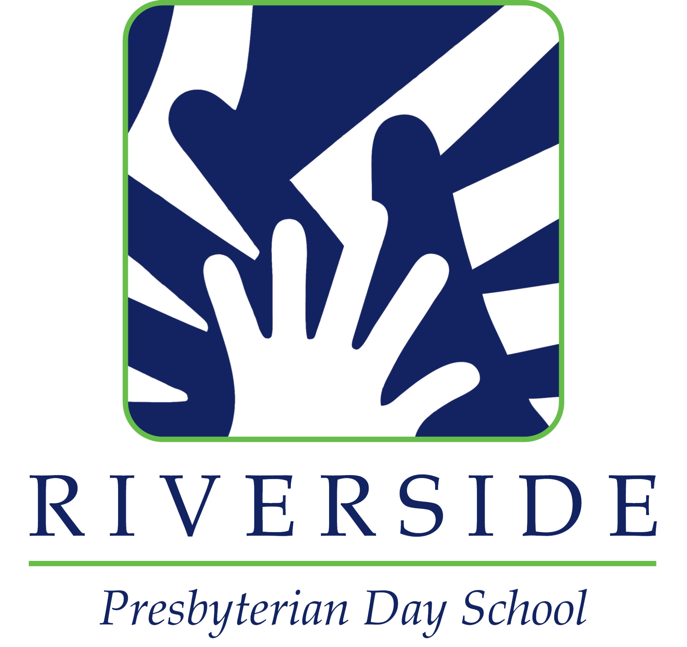

RIVERSIDE PRESBYTERIAN DAY SCHOOL
Kindergarten Teacher

Riverside Presbyterian Day School, an independent co-educational elementary (PreK 3 – 6th Grade) day school located in Jacksonville, FL seeks a full-time Kindergarten Teacher for the 2022-2023 school year.
Riverside Presbyterian Day School is an FCIS accredited, independent co-educational elementary day school located in Jacksonville, FL. Teachers at Riverside Presbyterian Day School participate fully in the life of the school. These duties and responsibilities include developing and delivering a robust curriculum, observing and assessing student progress, preparing written report card comments, participating in parent-teacher conferences, effectively communicating with students, parents, colleagues, and administrators, attending grade level and full faculty meetings, serving on content area or school life committees, and duties related to the supervision of lunch, recess, and dismissal.
RPDS teachers work in a tight community and team-teaching environment to coordinate, organize and deliver the challenging RPDS curriculum, which depending upon grade level utilizes thematic units or departmentalized instructional methodology. We are an educational community of “self-starters” who do not wait to be told to act. All teachers are vital ambassadors for the school.
RPDS faculty and staff are committed to providing an engaging academic program in a loving environment. Teachers are expected to model the stance of a lifelong learner, actively seeking out and participating in both school-based and off-site professional development that supports the Schools mission and goals.
General Responsibilities:
- To support the school mission to foster the intellectual, physical and spiritual growth of each child;

- To support colleagues and the school’s leadership to fulfill the school mission;

- To research, prepare and deliver captivating, developmentally appropriate content consistent with the school’s grade-level expectations and goals;

- To exercise appropriate classroom management and maintain classroom discipline;

- To complete all paperwork (i.e. recordkeeping, grading, reporting, etc.) relating to your teaching assignment in a timely fashion and as directed;

- To utilize strong interpersonal and communication skills in substantive, accurate and sensitive meetings with students and parents to properly share information relative to student progress;

- To actively participate in furthering curriculum development and assessment, resources, facilities, and activities that support your teaching area and to participate in furthering the educational model of the school;

- To display a willingness to advance your own educational and professional development through a demonstrated desire to keep “growing;”

- To display knowledge of child development theory and successful educational techniques and practice;

- To provide a happy, encouraging, supportive and caring environment for children;

- To exercise independent judgment, and to manage and impart confidential information;

- To actively participate in all scheduled meetings as required by school, administration and/or curriculum coordinator;

- To embrace modern technological methods of instruction, reporting and communication within the school community;

- To assist as necessary in the search for candidates to fill teaching vacancies;

- Assist other school duties as directed by the Assistant Head of School and/or the Head of School.

Qualifications & Skills:

● A Bachelor’s degree with teaching qualification or equivalent;
● Experience as an elementary classroom teacher with a proven track record of excellence in teaching and classroom management;
● A commitment to global and cultural competency, and a diverse, equitable, and inclusive community;
● A strong knowledge and understanding of child development and best practices in education;
● Outstanding interpersonal and problem-solving skills;
● A proven ability to use and integrate technology effectively into the classroom setting to enhance and enrich the student learning experience;
● Excellent verbal and written communication skills;
● Creative and visionary with a growth mindset and willingness to innovate and collaborate with others;
● Empathetic, supportive, good sense of humor, and a positive disposition.

