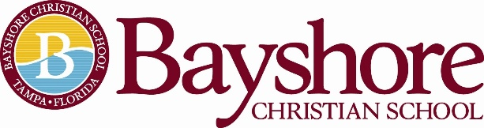
Bayshore Christian School is a private, evangelical, non-denomination Christian school serving students PK2-12th grade. Located in the heart of South Tampa, close to the Selmon Expressway and MacDill Air Force Base with easy access to the Brandon/Riverview area and St. Petersburg. Bayshore is widely recognized for its strong academics and Christ-centered, family environment.
We are seeking passionate candidates for a full time, upper division English teacher starting with the 2022-23 academic year.
Identification:
Instructional Teacher Temporary: Upper Division English Teacher
Classes could include but are not limited to:
English I, II, III, IV,
Advanced Placement Language/Literature
Direct Supervision: Head of School
Scope of Work: Full Time: Ten-month position
August 1, 2022 - May 30, 2023
Professional Qualifications
- The teacher has a minimum of a Bachelor’s Degree in Education and/or English or Literature.
  - Preferred Degree in education but not required.
  - Professional teaching certification preferred but not required.
  - Professional teaching experience of College Board classes.
- Preferred minimum three years teaching experience at the high school level.

Professional Behavior:
- The teacher is an evangelical, born again Christian.
- The teacher will regularly attend an evangelical, Christian church for spiritual growth.
- The teacher will adhere to Bayshore Christian School’s Faculty and Staff Handbook.
Please visit www.bayshorechristianschool.org to complete an online application. Submit your resume to Melanie Humenansky, Head of School at mhumenansky@bayshorechristianschool.org

