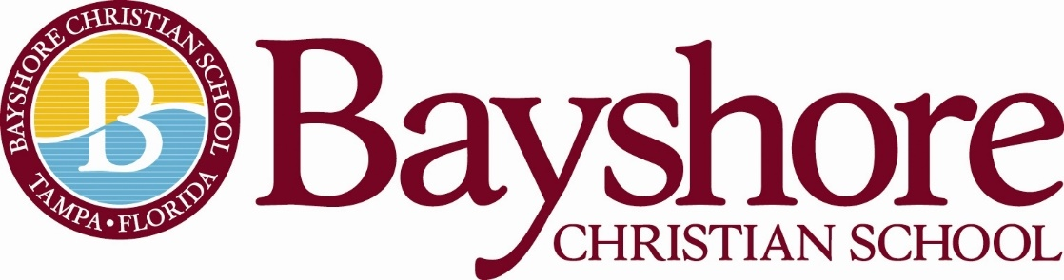

Director of Admissions

12-Month Employee: Full Time
School Year Hours: 7:30am-4:00pm
Summer Hours: TBD
Direct Report: Head of School
Job Description:

The Director of Admissions is an individual who wholeheartedly believes in the vision and mission of Bayshore Christian School and is able to successfully share that vision and mission, as well as the unique benefits of a Bayshore Christian School experience, with both current and prospective families, faculty, and staff.
Objective:
To effectively communicate the vision and mission of Bayshore Christian School to increase mission-supportive student enrollment.
To move qualified prospective students quickly and appropriately from inquiry and application status to full-time enrollment.
To organize, update, and secure student records. (Incoming and Outgoing)
Job Responsibilities:

Tours/Open Houses
FACTS SIS Management: Enrollment Dashboard
Intake and Organization of Admissions Documents and Processes:
FACTS Admissions Dashboard/Tracking Inquiries and Applications
Collaborate with Marketing/Director of Advancement: Data/Marketing/Incentives
Financial Aid (Confidential)
Tuition Contracts: Guide families through enrollment process
Field Phone Calls/Emails for New and Current Families
Manage the Admissions Process for International Students, including the processing of I-20 documents through SEVIS (Student and Exchange Visitor Information System)
Arrange Admissions testing both in-house and through the Educational Records Bureau
Maintain Employee Fingerprinting using the Falcon System (with support of Director of Administration)
Billing/Delinquency Management: Tuition and Incidental Billing/FACTS Tuition Management
Manage Scholarship Programs and Scholarship Compliance through Scholarship Organizations such as Step Up For Students and AAA Scholarship Foundation
Yearly Compliance Tasks: FLDOE, SUFS, SEVIS, DASL, Strategic Planning
Participate in professional development activities such as those provided by FCIS

Live the Biblical Characteristics of Professional Excellence of
Bayshore Christian School

Minimum Qualifications/Training and Experience

The administrator has a minimum of a bachelor's degree: Business/Marketing/Education
Preferred minimum of three years of experience - not required
Outgoing Personality: Team Player
Speaks Clearly and Displays Solid Listening Skills
Proficient in Technology: Microsoft Office Suite
Strong, Precise, Efficient and Excellent Communication Skills, Both Written and Verbal
Ability to Maintain Confidentiality in the Area of Student Records and Finances

Professional Behavior:

The administrator is an evangelical, born-again Christian.
The administrator will regularly attend an evangelical, Christian church for spiritual growth.
The administrator will adhere to Bayshore Christian School’s Faculty and Staff Handbook.

Mission and Vision:

The philosophy of Bayshore Christian School underlies the development and maintenance of the school’s entire program. This philosophy encapsulates our motto, vision, mission, and core values.

MOTTO
“We are Bayshore: Scholars, Leaders, Faith Warriors”

VISION
Shaping young people in Christ to make an impact in the world.

MISSION
Bayshore Christian School challenges, develops, and empowers students for leadership by following the example of Jesus to “grow in wisdom, stature, and in favor with God and man.” Luke 2:52

Statement of Faith
The Statement of Faith does not exhaust the extent of our faith. The Bible itself is the sole and final source of all that we believe. We do believe, however, that the Statement of Faith accurately represents the teachings of the Bible and therefore, is binding upon all teachers.
- We believe in God, the creator of heaven and earth.
- We believe God created male and female in His image.
- We believe God consecrated marriage as the union of a man and a woman.
- We believe in the trinity: God the Father Almighty, Jesus Christ, his only Son, and the Holy Spirit.
- We believe that Jesus is Lord; that he is divine, that he is God.
- We believe that Jesus was conceived by the Holy Spirit.
- We believe that Jesus was born of a virgin.
- We believe that Jesus atoned for the sins of all mankind when he was crucified.
- We believe that Jesus died and was buried.
- We believe that Jesus was resurrected from death and is alive today.
- We believe that Jesus sits at the right hand of the God the Father Almighty.
- We believe that Jesus will return to this earth to judge all mankind.
- We believe in everlasting life.
- We believe in the Bible as the inspired word of God, inerrant and true.

This job description does not list all the duties of the job. The candidate will also be expected to assist in all campus activities including but not limited to: Open Campus, Annual Fund, Fun Run, Christmas Musical, Spring Gala
Bayshore Christian School reserves the right to revise this job description at any time.
Above all else, he/she can support and uphold the Head of School and the Administration in all endeavors and present a united front to students, teachers, staff, Trustees, and all constituents.
Contact Person: Please email a resume and letter of interest to Head of School, Melanie Humenansky at mhumenansky@bayshorechristianschool.org. Please include any experience you may have in the area of marketing and communications, coaching, and/or sponsoring extra-curricular activities.

