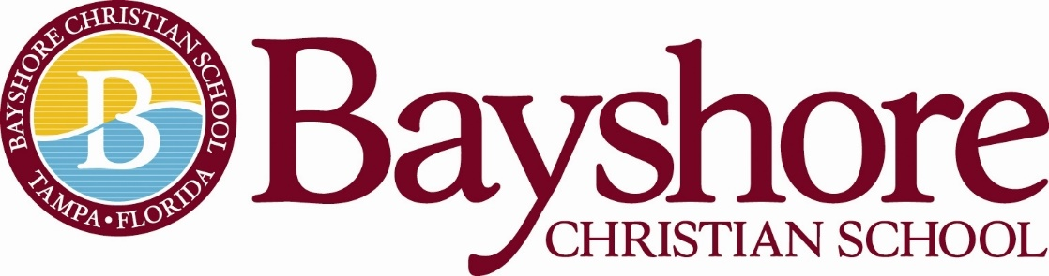

Director of Advancement

12-Month Employee: Full Time
School Year Hours: 7:30am-4:00pm
Summer Hours: TBD
Direct Report: Head of School
Job Description

Bayshore Christian School’s Director of Development is responsible for leading the school’s development efforts, including annual giving, fundraising events, and capital campaigns as well as overseeing alumni, grandparents, and external partnerships. The Director of Development is also responsible for working with the Head of School to identify additional revenue-generating streams that benefit the school. The Director of Development reports directly to the Head of School.
Job Responsibilities:

Fundraising
- Work with Head of School to establish fundraising goals for the year
  - The Annual Fund: Fall of School Year (August-October)
  - The Fun Run: Winer of School Year (November/TBD)
  - The Spring Gala (March/April)
    - Allocation of funds raised for each established initiative
- Educating families of school’s fundraising efforts
  - Working with Director of Admissions
  - Understanding independent school structure for additional philanthropic dollars
- Monthly Communication
  - BCS Faith Warrior Communication
  - Quarterly Alumni Newsletter
  - Business Sponsorships/Bayshore Business Partners
Communication/Technology
- Effective communication with constituents: Faculty, Staff, BCS Families, Alumni, Community Partners
  - Internal/External
  - Advancement goals
- Data management
- Ability to work with identified operating systems for communication and donor sites. For example: Constant Contact, FACTS Giving, FACTS SIS, Give Smart
Engagement of the Board of Trustees
- Establish trustee relationships
- Communicate fundraising initiatives
  - Create the fundraising message for the board
- Establish future campaigns with the board in support of the school vision
- Identify board prospects
Marketing in Partnership with Director of Admissions
- Social Media Outlets: FB, IG, Twitter
  - Social media campaigns
  - Website updates
    - Support BCS Support BCS
- Mass Media
  - Press releases
- Marketing Collateral
- Community outreach opportunities
  - Marketing and business partnerships
  - Military outreach
  - PTFW
Alumni Liaison
- Enhance alumni involvement
  - Graduating Senior Data Management
- Website upkeep
- Data Management from 1971
- Quarterly Newsletter
Accreditation in Partnership with Head of School and Director of Admissions
- Florida Council of Independent School
- Standards

Live the Biblical Characteristics of Professional Excellence of
Bayshore Christian School

Minimum Qualifications/Training and Experience
The administrator has a minimum of a bachelor's degree
Preferred minimum of three years of experience - not required.
Professional development attendance through FCIS

Professional Behavior:
The administrator is an evangelical, born-again Christian.
The administrator will regularly attend an evangelical, Christian church for spiritual growth.
The administrator will adhere to Bayshore Christian School’s Faculty and Staff Handbook.

Mission and Vision:
The philosophy of Bayshore Christian School underlies the development and maintenance of the school’s entire program. This philosophy encapsulates our motto, vision, mission, and core values.

MOTTO
“We are Bayshore: Scholars, Leaders, Faith Warriors”

VISION
Shaping young people in Christ to make an impact in the world.

MISSION
Bayshore Christian School challenges, develops, and empowers students for leadership by following the example of Jesus to “grow in wisdom, stature, and in favor with God and man.” Luke 2:52

Statement of Faith
The Statement of Faith does not exhaust the extent of our faith. The Bible itself is the sole and final source of all that we believe. We do believe, however, that the Statement of Faith accurately represents the teachings of the Bible and therefore, is binding upon all teachers.
- We believe in God, the creator of heaven and earth.
- We believe God created male and female in His image.
- We believe God consecrated marriage as the union of a man and a woman.
- We believe in the trinity: God the Father Almighty, Jesus Christ, his only Son, and the Holy Spirit.
- We believe that Jesus is Lord; that he is divine, that he is God.
- We believe that Jesus was conceived by the Holy Spirit.
- We believe that Jesus was born of a virgin.
- We believe that Jesus atoned for the sins of all mankind when he was crucified.
- We believe that Jesus died and was buried.
- We believe that Jesus was resurrected from death and is alive today.
- We believe that Jesus sits at the right hand of the God the Father Almighty.
- We believe that Jesus will return to this earth to judge all mankind.
- We believe in everlasting life.
- We believe in the Bible as the inspired word of God, inerrant and true.

This job description does not list all the duties of the job. The candidate will also be expected to assist in all-campus activities including but not limited to: Open Campus, Annual Fund, Fun Run, Christmas Musical, Spring Gala
Bayshore Christian School reserves the right to revise this job description at any time.
Above all else, he/she can support and uphold the Head of School and the Administration in all endeavors and presents a united front to students, teachers, staff, Trustees, and all constituents.
Contact Person: Please email a resume and letter of interest to Head of School, Melanie Humenansky at mhumenansky@bayshorechristianschool.org Please include any experience you may have in the area of marketing and communications, coaching, and/or sponsoring extra-curricular activities.

