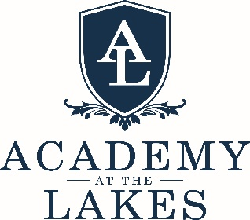

Upper Division Dean of Students
Academy at the Lakes seeks a passionate, experienced high school educator to serve as Upper Division Dean of Students. The Upper Division Dean of Students is the primary advocate for students in the division and is responsible for all non-academic, student-related matters. An effective Dean will work to cultivate a school culture of shared values and mutual respect; ethical, inclusive, and responsible behavior; and citizenship within and among our student body. This position will work collaboratively and in full partnership with the Upper Division Director, the Upper Division Assistant Director, and Student Support Team. The ideal candidate will be passionate about the development of student leadership, be aligned with Academy’s mission and core values, and desire to develop and lead programs and initiatives that support a healthy Upper Division culture guided by student agency and integrity.

