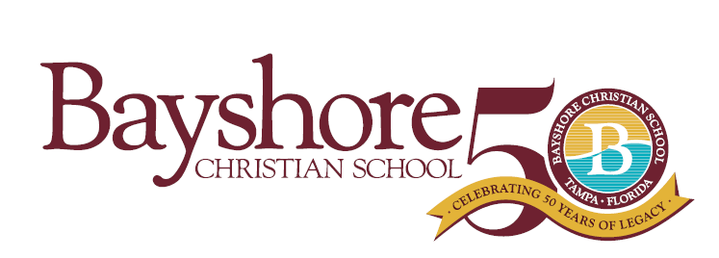
Bayshore Christian School is a private, evangelical, non-denomination Christian school serving students PK2-12th grade. Located in the heart of South Tampa, close to the Selmon Expressway and MacDill Air Force Base with easy access to the Brandon/Riverview area and St. Petersburg. Bayshore is widely recognized for its strong academics and Christ-centered, family environment.
We are seeking passionate candidates for a full time lower/middle division teacher to start in August 2022.
Instructional Teacher Lower Division (Kindergarten-5th Grade)
Direct Supervision: Head of School
Scope of Work: Full Time
August 2022-May 2023
Professional Qualifications
- Preferred Bachelor's Degree in Education or related field
  - Professional teaching certification is preferred but not required for initial hire.
    - Applicant’s willingness to sign an intent to earn for a teaching certificate in the state of FL within three years of hire.
    - Applicant’s willingness to sign an intent to earn an ASCI teaching certification within two years of hire.
- Preferred minimum three years teaching experience at the elementary and/or middle school level
Professional Behavior:
- The teacher is an evangelical, born again Christian.
- The teacher will regularly attend an evangelical, Christian church for spiritual growth.
- The teacher will adhere to Bayshore Christian School’s Faculty and Staff Handbook.
Please visit www.bayshorechristianschool.org to complete an online application. Submit your resume to Melanie Humenansky, Head of School at mhumenansky@bayshorechristianschool.org

