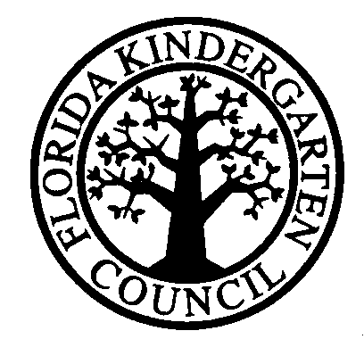

The Marian Krutulis
Convention Scholarship Application

The Florida Kindergarten Council provides leadership, accreditation and professional services to member schools with exemplary early childhood programs. FKC extends this commitment through two opportunities.

Open to All Members
of the Faculty, Staff and Administration
of FKC Member Schools

This scholarship provides complimentary registration to the FKC Convention by the Board of Directors to a member of an FKC school’s faculty, staff or administration. This is not a cash grant.

The purpose of the award is to support early childhood programs to enable educators to attend the annual FKC convention who might not otherwise attend due to limited funds.

Up to four (4) applications may be submitted from any one school. In some situations, having more than one person traveling together reduces costs so the Board may look more favorably at those applications.

Deadline for submitting application is Monday, November 6, 2017. Please note that all applications must carry endorsement of the school head. Use the application form on the FKC website http://www.fkconline.org/ and email application with signatures (applicant and school head) to lmenger@sjeds.org.

All applicants will be notified via email by December 1, 2017.

Schools that receive the FKC Convention Scholarship are asked not to apply again for two years so that other schools can benefit.

Any questions? Contact Lori Menger at (904)733-0352 or lmenger@sjeds.org.

APPLICATION

Applicant’s Name:

Email address(es):

Position(s) at School:

Name of School:

City: Zip:

How will attending the FKC Convention benefit you? Your school? Your students?

Signature of Applicant(s):

Endorsement (Signature) of School Head:

